Task 1:
- 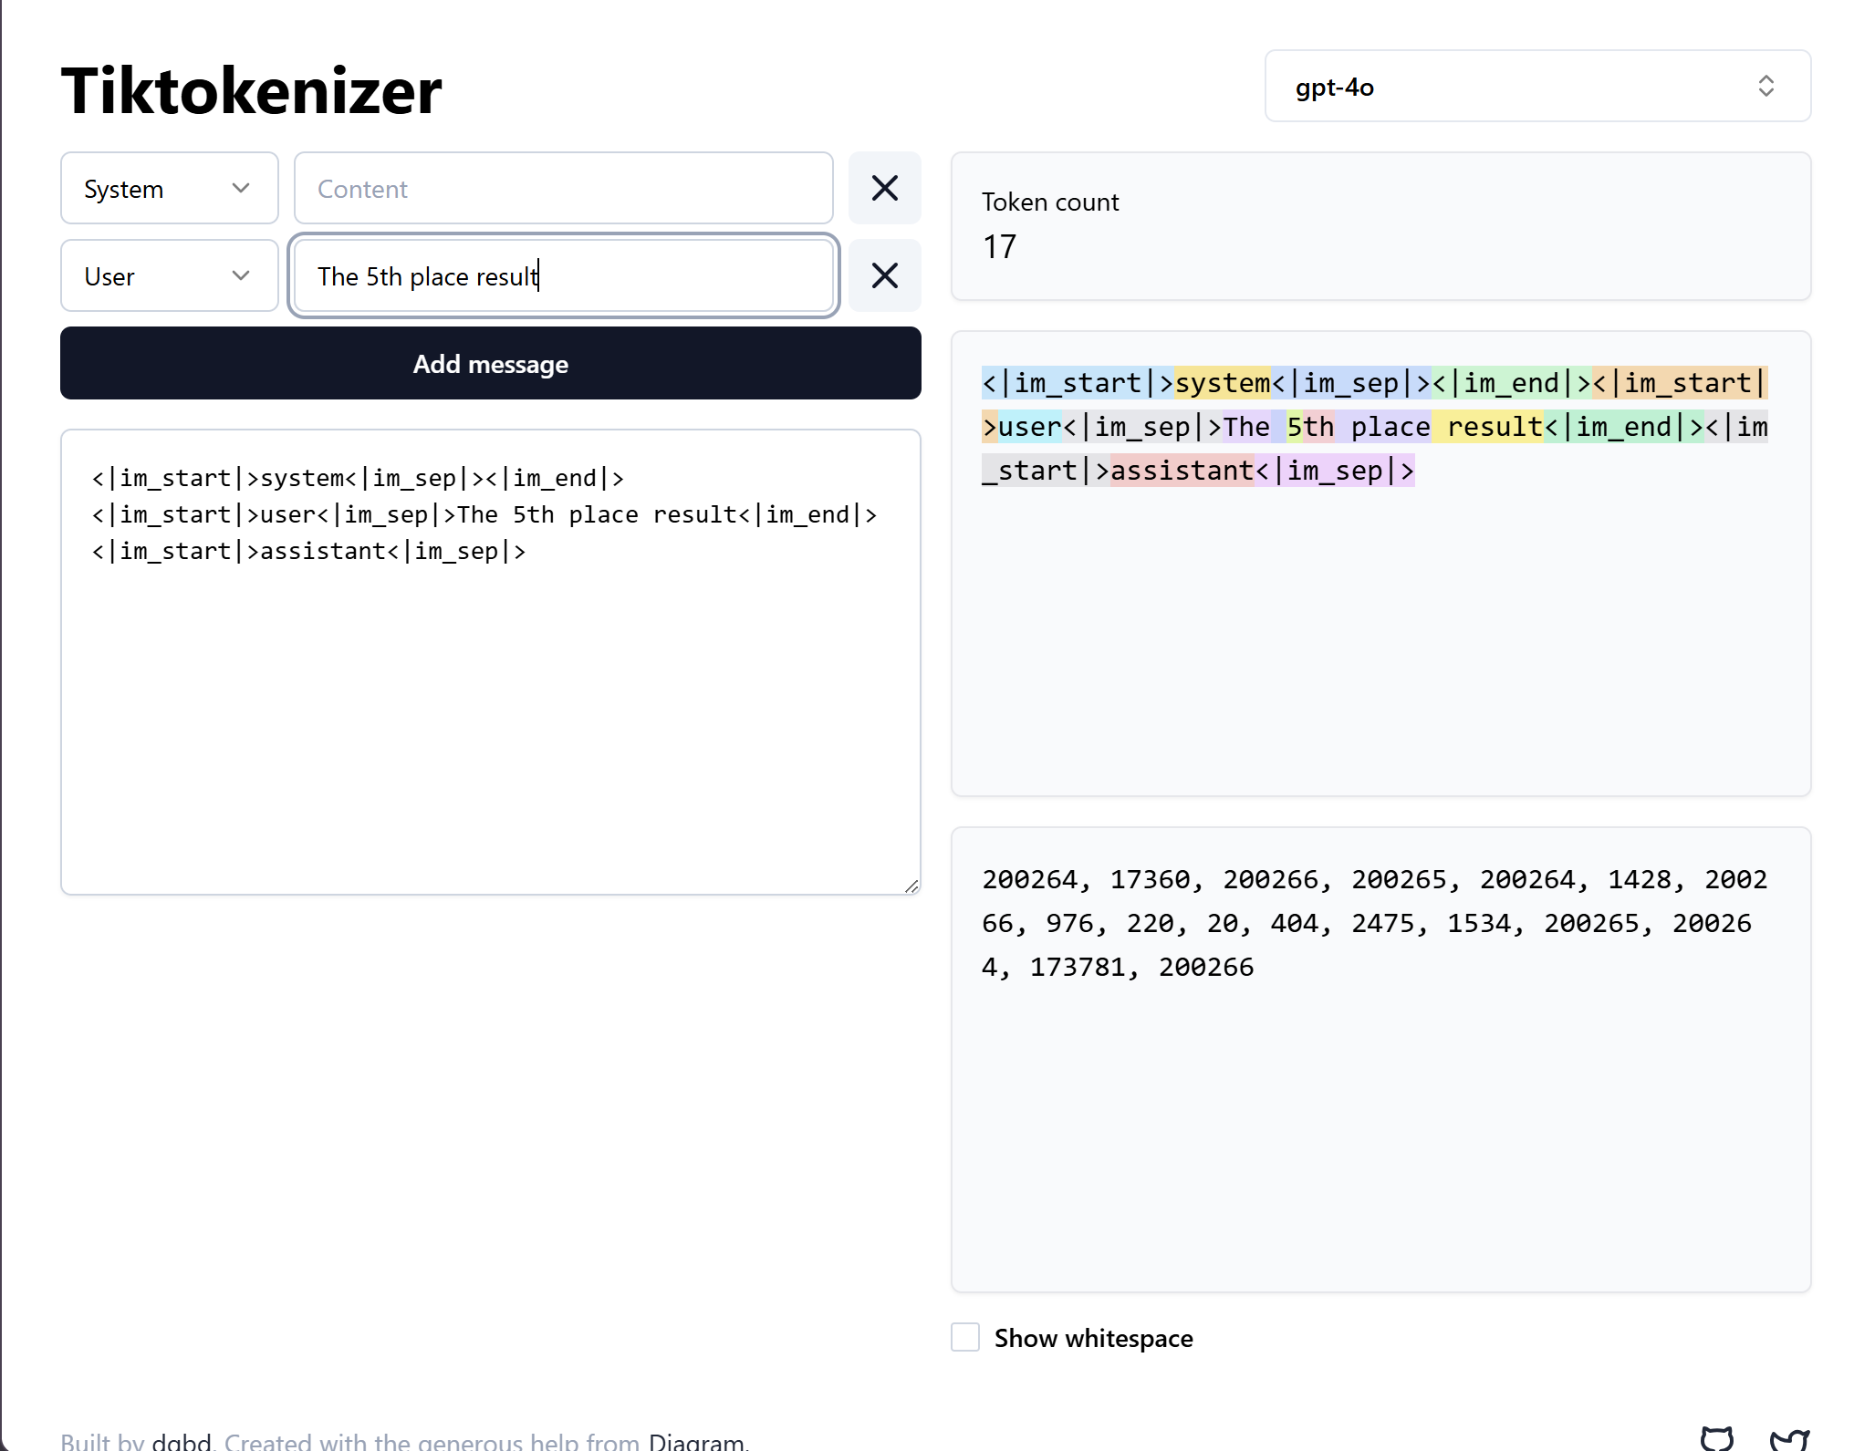
- 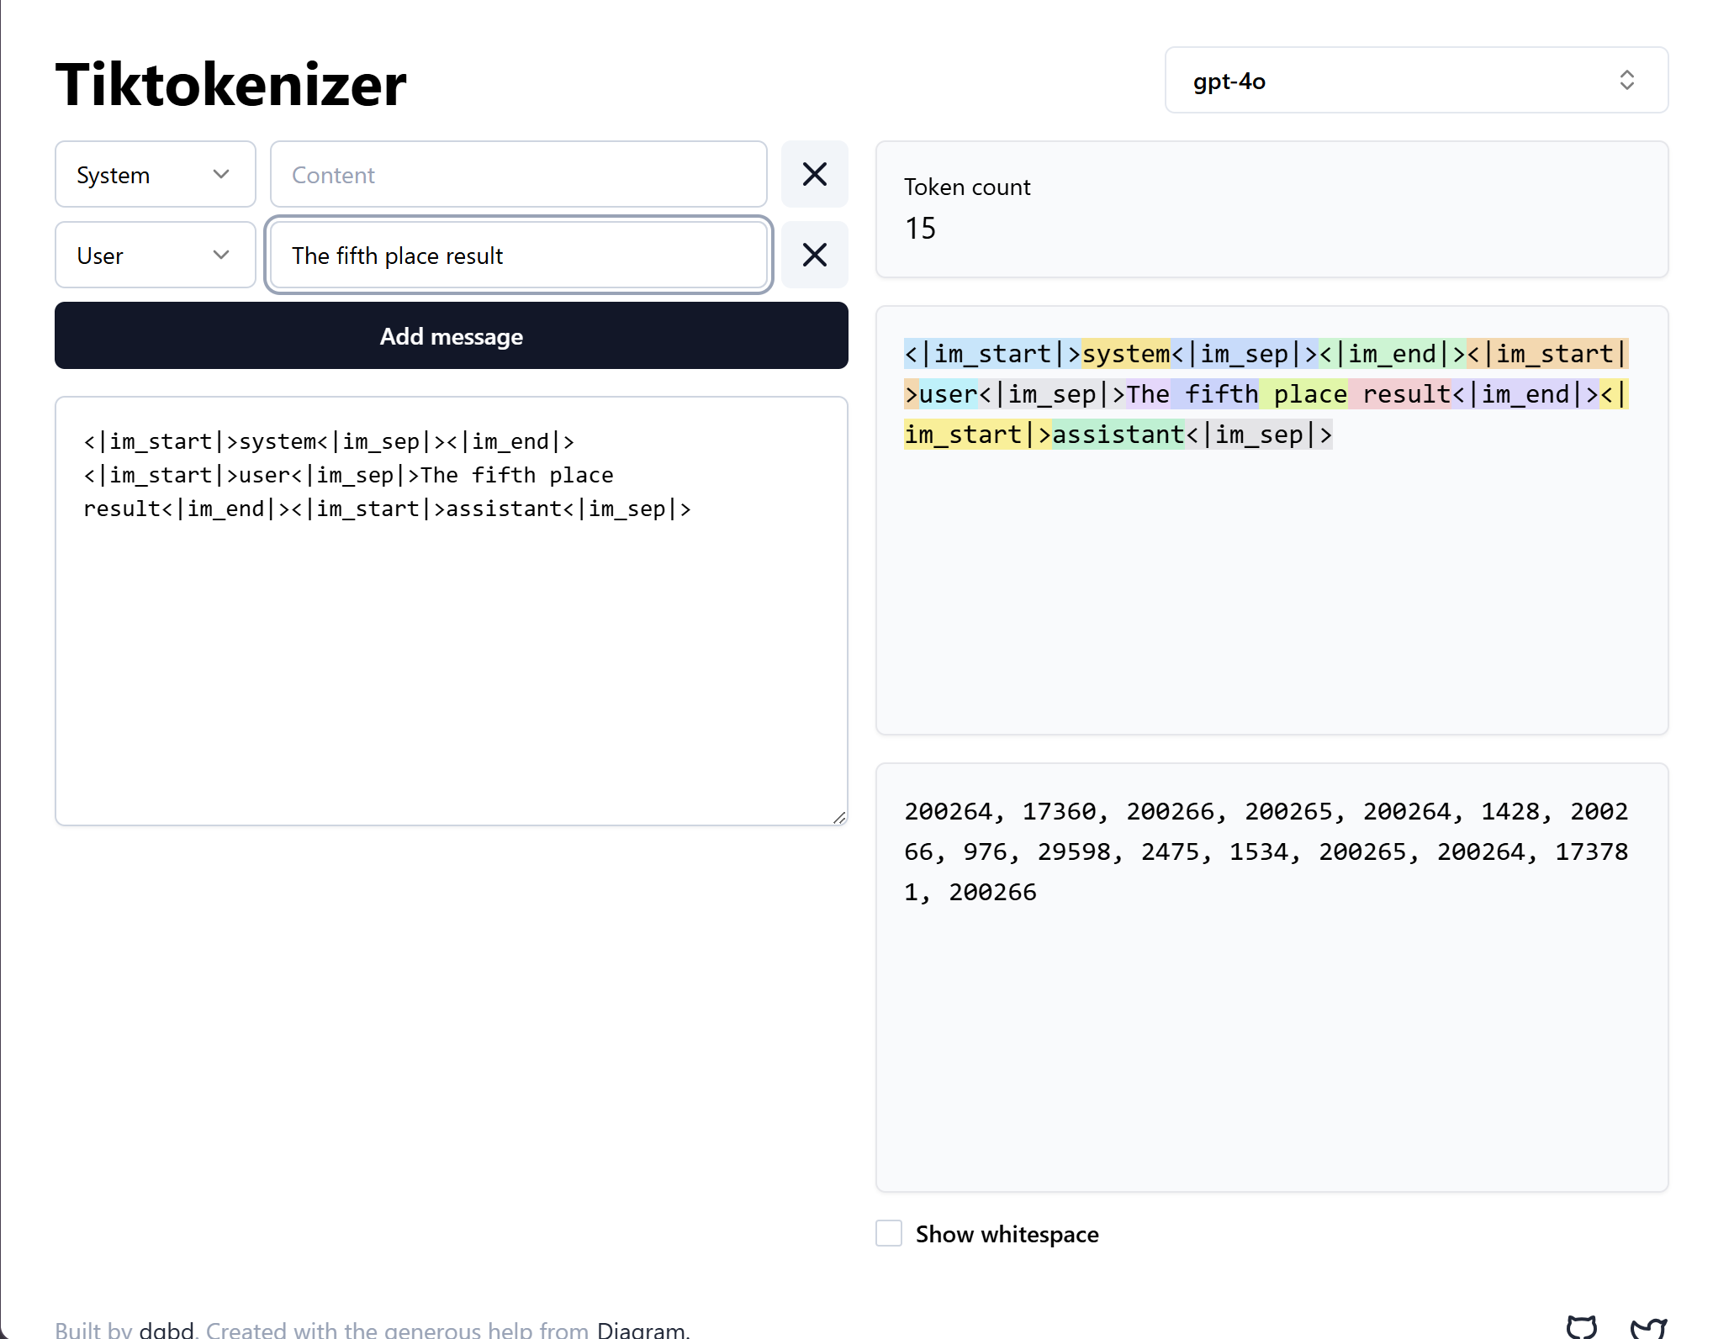
- In gpt-4o, When I use fifth, it is tokenized as one word, including the space as well however 5th tokenizes the space, 5 and th separately.
- Thus fifth uses less tokens in gpt-4o and is therefore more convenient, conveying the same message using less tokens
- It was tokenized similarly in deepseek r-1 aswell.

